**PROJECT ON DIGITAL MARKETING**

**NAME:SAKTHIVEL.AJ**

**TEAM MEMBERS:**

SAKTHIVEL.A.J(2CDB31AED0EF4E194B84B22FE766E635) (Member 2)

**TEAM NM ID:** NM2023TMID03440

**DEPARTMENT:** B.E COMPUTER SCIENCE AND ENGINEERING – FINAL YEAR

**COLLEGE: 8151-** DHANALAKSHMI SRINIVASAN INSTITUTE OF

TECHNOLOGY SAMAYAPURAM, TRICHY.

**NAANMUDHALVAN COURSE:** DIGITAL MARKETING

**PROJECT DESCRIPTION**

**PROJECT TITLE:** HOW TO BUILD AND EXECUTE THE ON-PAGE SEO FOR YOUR WEBSITE HOW TO BUILD ON-PAGE SEO FOR WEBSITE

**BRAND NAME:** I WORLD

**CATEGORY: “**I-PHONES AND I-PADS”

**TARGET AUDIENCE:** All (Men, Women and Adults)

**EMAIL:** **iworld.hello@gmail.com**

**RECORDED VIDEO**

[**https://drive.google.com/file/d/1FSkQhw4DpgvkwiyCu6zqqY6b0zcDKoAb/view?usp=drivesdk**](https://drive.google.com/file/d/1FSkQhw4DpgvkwiyCu6zqqY6b0zcDKoAb/view?usp=drivesdk)

**Documentation:**

**Headers:**



**Image alt text:**



**Meta Description:**

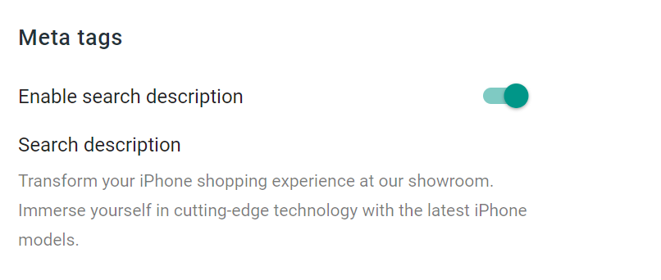

**Title:**

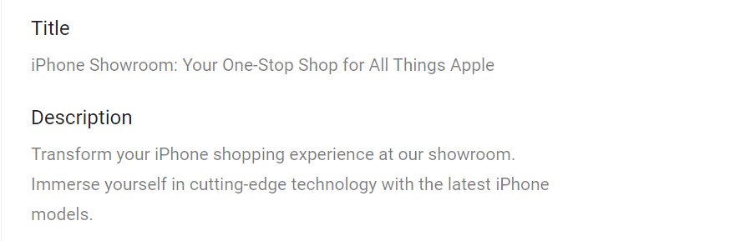

**Page URL:**



**External Linking:**

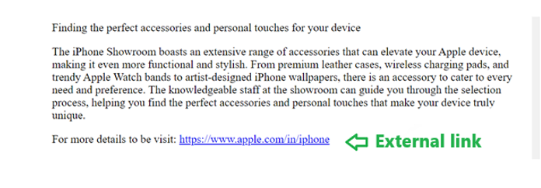



**Mobile Responsiveness:**

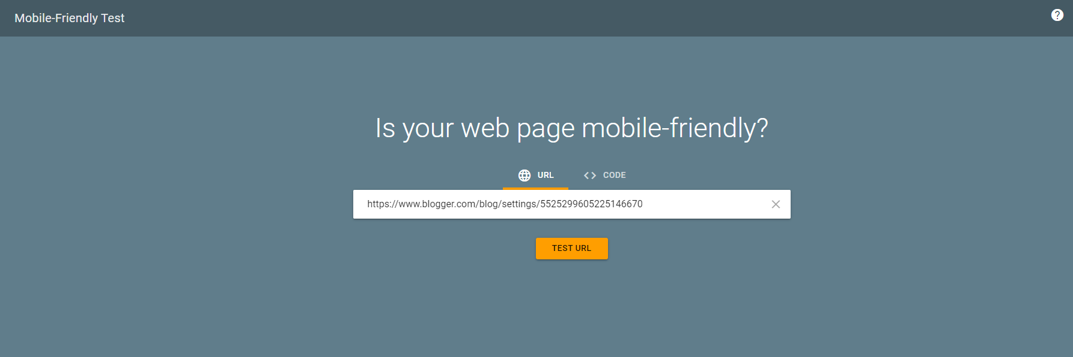



**Site Speed:**



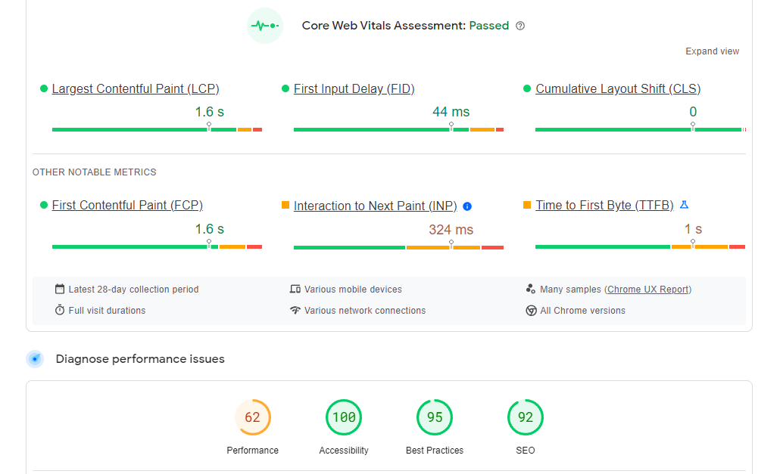

**Structured markup:**

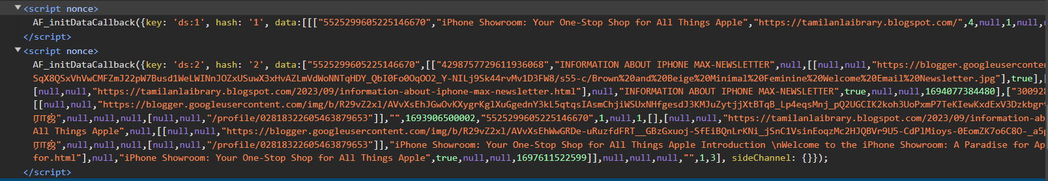

**Internal Linking:**

